Series RLC Circuit Model: Current vs. Rate of Change for Current

**Name: Christ-Brian Amedjonekou**

**Date: 04/03/2019**

**MAT 4880-D692 (Math Modeling II) RLC Model Project 2**

**Spring 2019, Section: D692, Code: 36561**

**Instructor: Johann Thiel**

# Abstract

In this study, we set out to create an RLC Model of a Simple Series RLC Circuit. The goal was to find the steady state of the dynamical system given the $\frac{dq}{dt}$ (rate of change of q) and its rate of change $\frac{d^{2}q}{dt^{2}}$ as state variables. *RLC* circuits are used in many electronic systems, most notably as tuners in AM/FM radios. These circuits can be modeled by second-order, constant-coefficient differential equations; This is what we did here. We created a continuous dynamical system from the second-order differential equation, as mentioned above. We used sage/python to model and analyze this problem. Once modeled, finding the equilibrium points to the system was the next step as they show the value in which the model reaches its steady state. Reaching the steady state (finding the equilibrium points) indicates that the recently observed behavior of the system will continue into the future. What that means for this problem is that we’ll expect the current and its of change to converge to a point and remain there, or at least this is what we believe. Finally, we classify the equilibrium points using the Eigenvalue Method, and show a graphic of the model in the form of a Phase Portrait.

# Introduction

*RLC* circuits are simple electronic circuits most commonly used as tuners in AM/FM radios, as well as other electronic systems. As aforementioned, we can model these circuits by second-order, constant-coefficient differential equations. For this report, our goal is to determine if the current and its rate of change will reach the steady state. In order to do that we convert the second-order differential ( $E\left(t\right)=L\frac{d^{2}q}{dt^{2}}+R\frac{dq}{dt}+\frac{1}{C}q$) into a continuous dynamical system, where we have charge ($x_{1}=q$) and current ( $x_{2}=I=\frac{dq}{dt}$) as the state variables. We’ll be looking to find the equilibrium points of the system as that will determine the steady state of the system; This will be verified through the Eigenvalue Method and displayed graphically in the form of a Phase Portrait.

# Assumptions and Definitions

For the model of the continuous dynamical system, we’ll assume the following:

$$E\left(t\right)=L\frac{d^{2}q}{dt^{2}}+R\frac{dq}{dt}+\frac{1}{C}q$$

$$Let x_{1}=q; x_{2}=I=\frac{dq}{dt}$$

$$\frac{∂x_{1}}{∂t}= \frac{dq}{dt}=x_{2}$$

$$\frac{∂x_{2}}{∂t}= \frac{d^{2}q}{dt^{2}}=\frac{E\left(t\right)-Rx_{2}-\frac{1}{C}x_{1}}{L}$$

* where $x_{1}=q=the charge of the capacitor$
* where $x_{2}=\frac{dq}{dt}=rate of change of the charge (current)$
* where $E\left(t\right)=Electric Potential of the RLC Circuit=300 V$

$R=resistance of the resistor=10 Ω$

$C=capacitance of the capacitor=\frac{1}{30} Farads$

$L=inductance of the Inductor=\frac{5}{3} Henries$

The reason we convert the second order differential equation to a continuous dynamical system is because we don’t have a method for evaluating a nonlinear second-order differential in its current form. As aforementioned we convert the second-order differential ($E\left(t\right)=L\frac{d^{2}q}{dt^{2}}+R\frac{dq}{dt}+\frac{1}{C}q$) into a continuous dynamical system, where we have charge ($x_{1}=q$) and current ( $x_{2}=I=\frac{dq}{dt}$) as the state variables. We are given the values for the resistor ($R=10 Ω$), capacitor ($C= \frac{1}{30} Farads$), and inductor ($L=\frac{5}{3} Henries$). The resulting dynamical system is $\frac{∂x_{1}}{∂t}= x_{2}$; $\frac{∂x_{2}}{∂t}=\frac{3}{5}(300-10x_{2}-30x_{1})$.

# Analysis

To solve the system, we set both differential equations to 0; Solving for the equations set to 0 gives the equilibrium points. This is because if the rate of change is 0, it means there is no change and the dynamical system has reached the steady state. Python, specifically the Sympy (Symbolic Python) package, was used to find the result for the system. $x_{1}=10;x_{2}=0$ are the equilibrium points to the system. To classify the equilibrium points, we used the Eigenvalue Method. Simply put, we calculated the Jacobian Matrix (using a python function and SciPy), found the determinant ( $\det\left(A-λI\right)=0$), and solved for $λ$. The Jacobian Matrix is shown in Figure 1. We found that $λ_{1}=-3+3i;λ_{2}= -3-3i$. Since both eigenvalues have a negative real part we classify the equilibrium point (10, 0) as stable. Other Python packages, specifically NumPy (Numerical Python) and Matplotlib (Plotting Package), were used to plot the Phase Portrait of the nonlinear system to determine which equilibrium the vectors converge to. This is shown below in Figure 2 below:

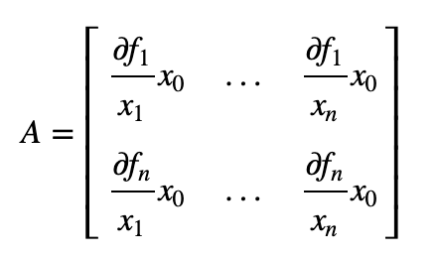

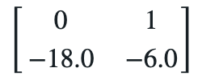

*Figure 1: Jacobian Matrix for RLC Circuit Continuous Dynamical System*

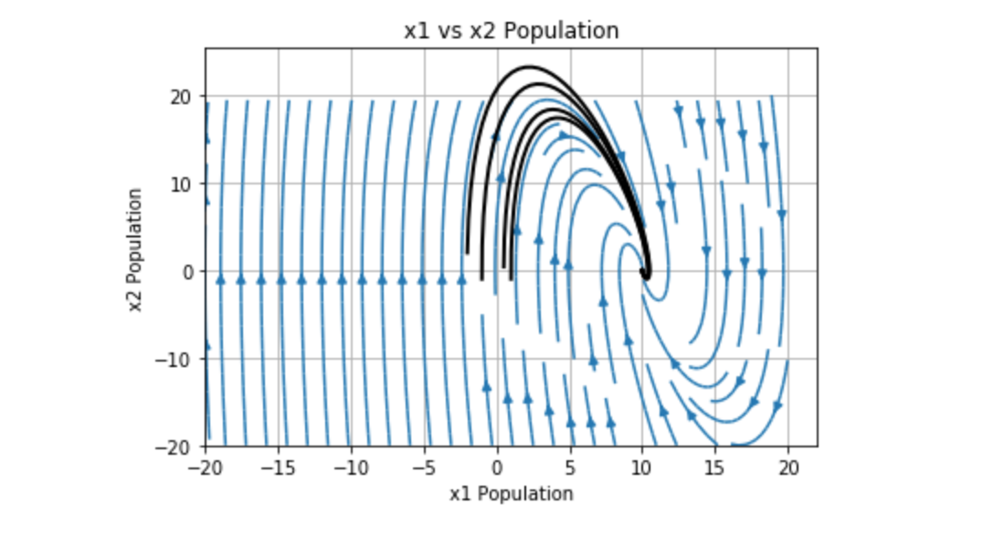

*Figure 2: Phase Portrait for RLC Circuit Continuous Dynamical System*

The Phase Portrait shows that the vectors of the dynamical system converge to $(10, 0)$, which seems to indicate the current vs. its rate of change will be stable at that point. The Trajectory Lines further demonstrates this, as they also converge to $x_{1}=10;x_{2}=0$ in the form of a spiral as this is determined by the eigenvalues.

# Interpretations and Conclusions

Based on the results obtained from Eigenvalue Method, where both eigenvalues had negative real parts, we can assume that current and its rate of change will reach the steady state at $x_{1}=10;x_{2}=0$ and stay there for future events. This is also supported by the Phase Portrait as the trajectory lines travel in a spiral towards the equilibrium point.